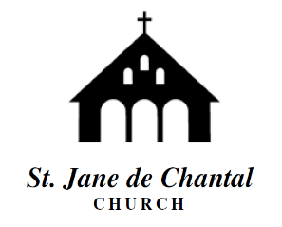

***Please Prayerfully Consider Nominating Yourself or Another to Join the Council.***

**NOMINATIONS MUST BE RECEIVED IN THE PARISH OFFICE BY 3:00PM (ET) DECEMBER 7, 2020.**

Please obtain permission and endorsement before nominating another individual. Completed forms may be placed in the “PC Nomination Box” located in the Narthex, or mailed to the Parish Office, Attn: Mr. Paul Eder, 9701 Old Georgetown Rd., Bethesda, MD 20814. Contact the Parish Office for additional Information (301) 530-1550

The Pastoral Council is a volunteer organization of elected Parishioners who advise the Pastor on a wide range of Parish and Community issues. No special training or experience is required. Nominees must be 18-years old, a registered Parishioner, and a practicing Catholic in good standing with the Church and neighboring community.

**St. Jane Frances de Chantal**

**Pastoral Council Membership Drive and Elections**



